Canvas

📘 Definition
# Source: AI Source: Provided by: [Data Path: Persons Table -> ID Column: 1, Name_En Column: Motasem Essam] -> From: [ChatGPT] on [5/2/2026]
A canvas is a blank drawing surface used to create images, graphics, or animations. In computer graphics, it acts like an empty area where shapes, text, and images are drawn using code or tools.

💻 Canvas in computer graphics
# Source: AI Source: Provided by: [Data Path: Persons Table -> ID Column: 1, Name_En Column: Motasem Essam] -> From: [ChatGPT] on [5/2/2026]

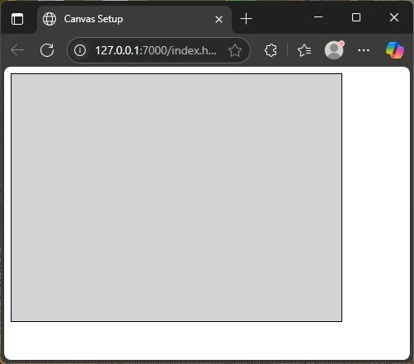
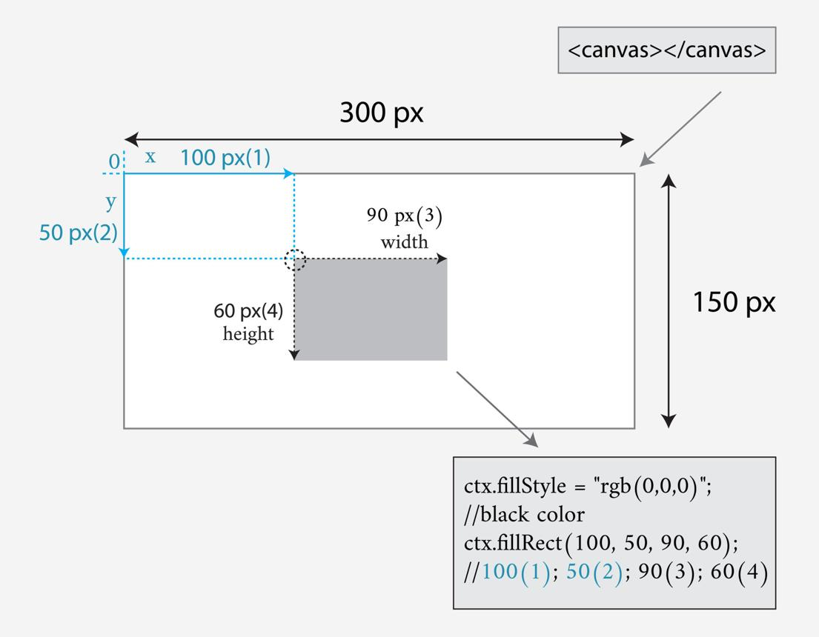
- It starts as a blank space
- You can draw lines, shapes, images, and animations
- Everything is created using coordinates (x, y)
- Used in programming (like HTML5 Canvas) and design tools

🧠 Simple example
# Source: AI Source: Provided by: [Data Path: Persons Table -> ID Column: 1, Name_En Column: Motasem Essam] -> From: [ChatGPT] on [5/2/2026]
Think of:
- 🎨 A painting canvas where an artist draws
- 🖥️ A digital drawing app screen
- 🎮 A game screen where graphics are displayed
All of these are types of canvas surfaces.

🎮 Where canvas is used
# Source: AI Source: Provided by: [Data Path: Persons Table -> ID Column: 1, Name_En Column: Motasem Essam] -> From: [ChatGPT] on [5/2/2026]
- 🎨 Digital drawing and painting apps
- 🌐 Web development (HTML5 Canvas)
- 🎮 Game graphics and animations
- 📊 Data visualization (charts and graphs)

⚙️ Key features
# Source: AI Source: Provided by: [Data Path: Persons Table -> ID Column: 1, Name_En Column: Motasem Essam] -> From: [ChatGPT] on [5/2/2026]
- 🖼️ Acts as a blank drawing area
- 📍 Uses coordinates for positioning
- 🎨 Supports shapes, images, and text
- ⚡ Can be updated dynamically (animations)

🚀 In short:
# Source: AI Source: Provided by: [Data Path: Persons Table -> ID Column: 1, Name_En Column: Motasem Essam] -> From: [ChatGPT] on [5/2/2026]
Canvas = a blank digital surface used to draw and create graphics, images, and animations.

